**Lecture 12: Search**

**Search**

: Finding data from multiple sources

**Sequential Search**

– The simplest search method.

– Check an unordered array sequentially

Time complexity:O(n)

**Improved Sequential Search**

• Save the search key at the end of list • Terminate the loop when finding key value

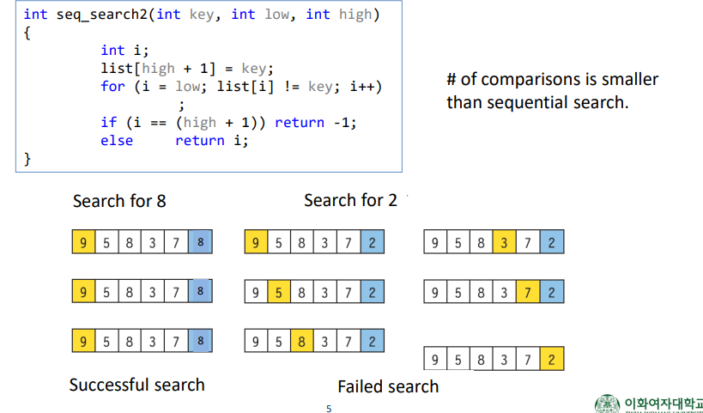

**Binary Search**

**:** Suitable for searching in an ordered array

• Procedure

1. Start at the center of the array

2. If the search key is identical to the value at center, terminate it.

3. Otherwise, go to left or right sub-array

4. Repeat 2 and 3 until finding the key or the sub-array is null

•Time complexity: O(log2N)

**Indexed Sequential Search**

• Index table

– is used to increase the efficiency of sequential search

– stores data regularly sampled from the input data list

• Assumption – Both the input data list and the index table are sorted

m: Index table size

n: size of main data list

• Time complexity: O(m+n/m)

**Interpolation Search**

• A method for predicting the location of a search key

• It is similar to the binary search, but the list is unevenly divided

• It works well when the data is relatively evenly distributed.

